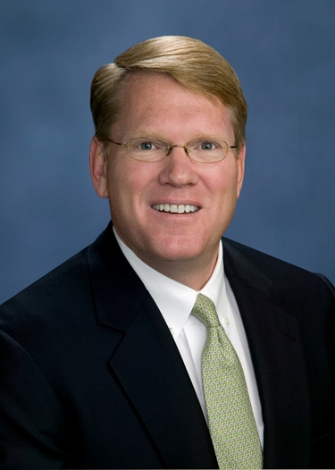 | Robert O. Cromwell, II  Managing Director  Office Services
As a Principal of Moody Rambin and Managing Director of the Office Services Division, Bob is directly responsible for formulating marketing, leasing and property management strategies for the company’s office portfolio, consisting of over 7 million square feet and located throughout virtually every submarket in the greater Houston area. With a depth of experience honed from his involvement in over 1,300 transactions, Bob directs daily operations for a growing team of leasing associates and property management professionals.
Education |  | Major Transactions
BA Texas State University |  | Tenant | Location | Square Feet
 |  | Total Petrochemical | CBD | 225,000
Affiliations |  | PricewaterhouseCoopers | CBD | 142,000
Licensed Real Estate Broker – State of Texas |  | Geico | Katy Fwy West | 130,000
Member of the Texas Association of Realtors |  | Conoco Phillips Energy | Katy Fwy West | 102,000
Houston Office Leasing Association Board Member |  | Reliant Energy | CBD | 101,000
 |  | Hilcorp Energy | CBD | 98,000
Partial Client List |  | Houston Housing Authorities | Galleria | 68,000
Shorenstein |  | Total Exploration Production | CBD | 68,000
Falcon Southwest |  | FloaTEC | Katy Fwy West | 62,026
TA Realty |  | ENI US Operations | CBD | 59,000
Coast Range |  | GL Noble Denton | Katy Fwy West | 55,066
Carval |  | Elite Transportation | Greenspoint | 45,000
Beacon Investments |  | Wells Fargo Bank NA | CBD | 40,000
Myers Crow & Saviers |  | HRH Insurance | Katy Freeway | 28,000
 |  | Seneca Resources | CBD | 25,000
 |  | Total Gas & Power | CBD | 25,000
 |  | Vopak | West Loop | 24,408
 |  | Andrews & Kurth | CBD | 20,000
 |  | Waste Corp America | West Loop | 16,515
 |  | Entrust | Katy Fwy West | 15,066

